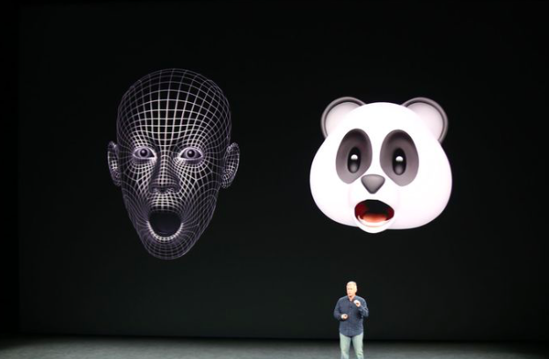

Customer and Investors Sentiments – Apple

Vinod Joshi (11810037) | Meenakshi Naren (11810030)

28-Dec-2018

# Executive Summary

This report provides an analysis of the current customer and investor sentiment about Apple Inc. based on the close observation of their flagship product iPhone. iPhone contributes to approximately 60% of the Apple’s revenue, hence the methods of analysis includes a close observation of iPhone sales trend, stock price, service consumption, news, consumer sentiments and compete from the same sector. Results of the analysis show that the recent plunge in Apple’s performance is a reflection of a systematic decline in the sector as opposed to a concrete resemblance of the customer or investor sentiment.

The report finds that Apple Inc. still demonstrates a healthy performance of its flagship product and any inference to its performance would be too early a call.

The report also acknowledges some limitations in the analysis that includes: non-availability of geographic distribution of iPhone sales, lack of age-group based sales distribution, limited information about OnePlus Stock (a compete that is growing rapidly but privately held) and unavailability of App Store’s data for analysis of the paid services consumption.

# Business Problem

iPhones sales in 2018 haven’t shown any increase over the number from the previous year (2017). There hasn’t been a new major product release in the last few years. Apple Inc. stock tumbled more than 30% in the last quarter. Apple Inc. lost its top spot to Microsoft as the company with highest market cap. This could reflect the customer and investor sentiment. As such there are numerous questions that we would like to answer: Is Apple’s customer base diminishing? Is it experiencing a stagnation in growth? Are investors losing faith in the company and its brand? Is there a need for a drastic measure to revive the company?